SIMATS ENGINEERING
ASSESSMENT TOOL 1
COURSE NAME: INTERNET PROGRAMMING
COURSE CODE: CSA43
Chunduri Naga sai Srikanth 192311159
COURSE OUTCOME COVERED
CO-1 : Develop well-structured, standards-compliant web pages using HTML/XHTML and XML, and apply Internet protocols and HTTP communication mechanisms for web content delivery. (L2)
Assessment Tool : Application-Based Questions
Weightage: 40%
QUESTIONS: Total Marks: 30

1: Online Symposium Portal
A college is developing an online symposium registration portal. The following HTML structure and HTTP interaction is observed:
<form action="/register" method="POST">
<input type="text" name="name">
<input type="email" name="email">
<button>Submit</button>
</form>
When a student submits the form, the browser sends an HTTP request to the server, and the server responds accordingly. Questions:
- Identify appropriate HTML5 semantic elements missing in the structure.
- Modify the structure to make it standards-compliant.
- Interpret the HTTP request generated during form submission.
- Analyze the HTTP response cycle from server to browser.
- Suggest improvements for usability and accessibility.

2: Cross-Browser Compatibility Issue
A company website shows inconsistent layout across browsers. The following HTML snippet is used:
<html>
<head>
<title>Company</title>
</head>
<body>
<div>
<h1>Welcome
<p>About us
</div>
</body>
</html>
Questions:
- Identify improper nesting and missing closing tags.
- Analyze how different browsers may interpret this structure.
- Identify missing semantic elements (e.g., header, section).
- Provide a corrected W3C-compliant HTML structure.
- Suggest techniques to ensure cross-browser compatibility.

3: Form Submission Failure
A web application fails to send form data to the server. The following configuration is observed:
<form action="/submit" method="GET">
<input type="text" name="username">
<input type="password" name="password">
<button type="button">Login</button>
</form>
Questions:
- Identify issues in the form configuration.
- Analyze why the HTTP request is not triggered.
- Interpret the role of GET method in this scenario.
- Propose a corrected implementation.
- Suggest improvements for secure data transmission.
Code of Conduct:
I Chunduri Naga Sai Srikanth (192311159) (Name / Reg No) certify that this submission is my original work and that I have adhered to the guidelines specified for this assessment. I understand that any violation of academic integrity rules will result in disciplinary action.
Signature of the student:
Chunduri Naga Sai Srikanth
RUBRICS FOR CALCULATION:

Criteria | Weig htage | Level 4 –  Exemplary | Level 3 –  Proficient | Level 2 –  Developing | Level 1 –  Beginning
Understanding of Concepts | 25% | Demonstrates thorough, accurate  understanding of concepts | Good understanding with minor gaps | Basic understanding with some  misconception s | Poor understandin g; major  misconceptio ns
Explanation | 25% | Detailed, wellexplained answers with relevant examples | Clear explanation with adequate  details | Limited explanation; lacks depth | Poor or unclear explanation
Application | 20% | Effectively applies concepts with strong analytical ability | Applies concepts with minor errors | Limited application  with weak analysis | No  application or incorrect analysis
Organization | 15% | Well-structured answers with logical flow and coherence | Organized with minor issues in flow | Basic structure, lacks clarity | Poor organization,  incoherent answers
Accuracy | 10% | Completely accurate and covers all required points | Mostly accurate with minor omissions | Partially correct with missing points | Incorrect answers with major gaps
Clarity | 5% | Clear, neat, professional presentation | Understandable with minor issues | Limited clarity, readability issues | Poorly written,  difficult to understand

Answers
1. Online Symposium Portal
1. Identify missing HTML5 semantic elements.
- <header> – Defines the page header.
- <main> – Defines the main content.
- <section> – Groups related content.
- <footer> – Defines the footer.
2. Modify the structure to make it standards-compliant.
<!DOCTYPE html>
<html lang="en">
<head>
<meta charset="UTF-8">
<title>Symposium Registration</title>
</head>
<body>
<header>
<h1>Online Symposium</h1>
</header>

<main>
<section>
<h2>Student Registration</h2>
<form action="/register" method="POST">
<label for="name">Name:</label>
<input type="text" id="name" name="name" required>

<label for="email">Email:</label>
<input type="email" id="email" name="email" required>

<button type="submit">Submit</button>
</form>
</section>
</main>

<footer>College Symposium</footer>
</body>
</html>

Output:
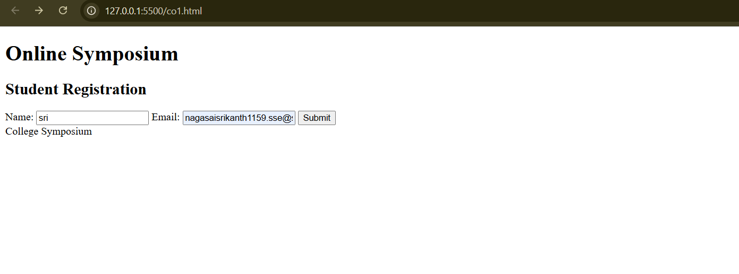
3. Interpret the HTTP request.
- The browser sends a POST request to /register.
- Form data is sent in the request body.
- The name and email fields are submitted.
- The server processes the registration.
4. Analyze the HTTP response cycle.
- Browser sends the request.
- Server receives and validates the data.
- Server saves the registration if valid.
- Server sends an HTTP response, such as 200 OK or 201 Created.
- Browser displays the response or confirmation page.
5. Suggest usability and accessibility improvements.
- Add labels for all input fields.
- Use required for mandatory fields.
- Use appropriate input types.
- Provide clear error messages.
- Ensure keyboard navigation and sufficient color contrast.

2: Cross-Browser Compatibility Issue

1. Identify improper nesting and missing closing tags.
- The <h1> tag is not closed.
- The <p> tag is not closed.
- The document is missing <!DOCTYPE html> and the lang attribute.
2. Analyze how different browsers may interpret the structure.
- Browsers may automatically insert missing closing tags.
- The resulting DOM may differ from the intended structure.
- Layout and styling can become inconsistent across browsers.
3. Identify missing semantic elements.
- <header> – Page heading.
- <main> – Main page content.
- <section> – About Us content.
- <footer> – Footer information, if needed.
4. Provide corrected W3C-compliant HTML.
<!DOCTYPE html>
<html lang="en">
<head>
<meta charset="UTF-8">
<meta name="viewport" content="width=device-width, initial-scale=1.0">
<title>Company</title>
</head>
<body>
<header>
<h1>Welcome</h1>
</header>

<main>
<section>
<h2>About Us</h2>
<p>Welcome to our company website.</p>
</section>
</main>

<footer>
<p>Copyright 2026</p>
</footer>
</body>
</html>
Output:
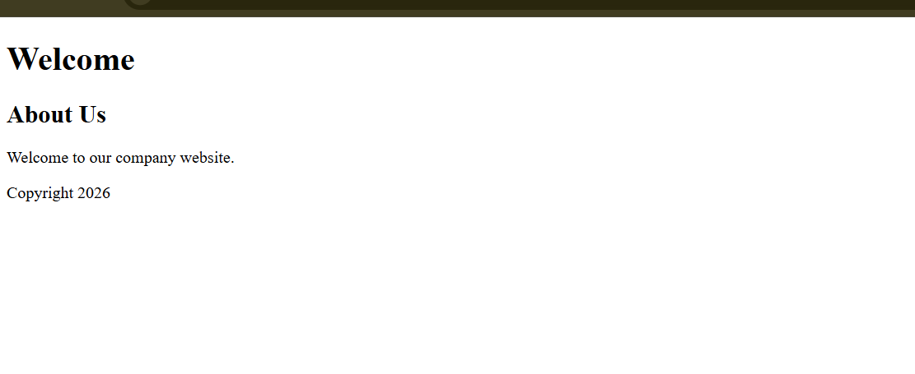
5. Suggest cross-browser compatibility techniques.
- Validate HTML using the W3C Validator.
- Use standard CSS and HTML.
- Test in Chrome, Firefox, Edge, and Safari.
- Use responsive design and CSS resets where appropriate.

3. Form Submission Failure
1. Identify issues in the form configuration.
- The button has type="button" instead of type="submit".
- The password is submitted using the GET method, which is insecure.
- Input fields lack labels and validation.
2. Analyze why the HTTP request is not triggered.
- A button with type="button" does not submit the form by default.
- Therefore, clicking Login does not automatically send the form data to the server.
3. Interpret the role of the GET method.
- GET sends form data in the URL as query parameters.
- URLs may be stored in browser history and server logs.
- It should not be used to transmit passwords.
4. Propose a corrected implementation.
<!DOCTYPE html>
<html lang="en">
<head>
<meta charset="UTF-8">
<title>Login</title>
</head>
<body>
<h1>Login Form</h1>

<form action="/submit" method="POST">
<label for="username">Username:</label>
<input type="text" id="username"
name="username" required>

<label for="password">Password:</label>
<input type="password" id="password"
name="password" required>

<button type="submit">Login</button>
</form>
</body>
</html>
Output:
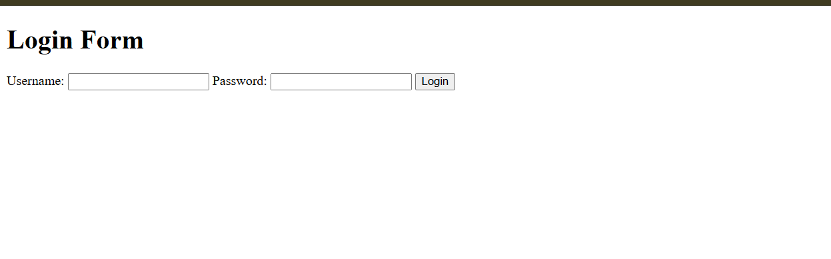
5. Suggest improvements for secure data transmission.
- Use HTTPS to encrypt data during transmission.
- Use the POST method for login credentials.
- Validate input on both the client and server.
- Store passwords using secure password hashing.
- Use secure session management and rate limiting.

